Help make a difference!  The future of Rotary and the service we give to our community locally and internationally depend on strong club leadership.  The Rotary Leadership Institute (RLI) is a series of fast paced, interactive, in-person or on-line courses offered to hone a Rotarian’s leadership skills and increase the knowledge of Rotary.  Courses are fun, topical, hands-on and geared toward busy professionals who want to be more effective, knowledgeable leaders in their vocations and in their Rotary clubs.  Participants return to their clubs with enthusiasm, fresh ideas, and invaluable leadership skills. | Why should your club participate in RLI?  Rotary clubs need the best leadership possible. Your key people can gain knowledge through exchanging ideas with experienced Rotarians and their clubs’ members. Feedback from past participants tells us that the courses are worthwhile.  Become empowered!  What is in it for you?  - Learn from others and gather ideas that you can put to use.  - Challenge your thinking, learn to think laterally, and try new ideas.  - Discover how being a Rotarian is an opportunity for personal growth and fulfillment.  - Go back to your club with fresh ideas, new tools, new contacts, and an increased motivation to take action! |   Who can/should participate in RLI?  RLI is open to all Rotarians.  How much does it cost to attend RLI?  Course fees are determined by the District Coordinator and RLI-HOA Registrar, and are based on site costs, meals, materials, and other expenses. Many clubs will cover the registration costs of their members.  Who are the RLI faculty?  Faculty members are drawn from all areas of your District and are carefully selected for their experience and facilitation skills.
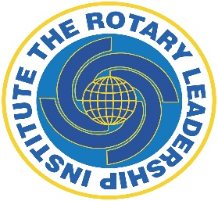  The Rotary Leadership Institute was founded to assist in improving the Rotary knowledge and leadership skills of the future leaders of our Rotary clubs and Districts.  “We believe that excellent leadership is the key to successful service by our clubs to our communities and the world. Rotary is blessed with members of high quality, but all Rotary clubs depend on outstanding leadership to harness the talents and skill of our membership to high levels of accomplishment.  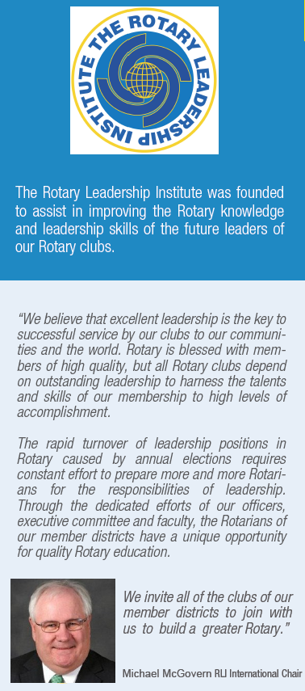  “The rapid turnover of leadership positions in Rotary caused by annual elections requires constant effort to prepare more and more Rotarians for the responsibilities of leadership. Through the dedicated efforts of our officers, executive committee and faculty, the Rotarians of our member districts have a unique opportunity for quality Rotary education.  “We invite all of the clubs of our member districts to join with us to build a greater Rotary.”  Michael McGovern, RLI International Chair | RLI is a multi-district leadership program with a mission to strengthen Rotary clubs through quality leadership education.    RLI provides an opportunity for all Rotarians, not just club leaders. You will learn to be more effective in your club and be on the leading edge of a changing world.  As a Rotarian you are already a leader, in your community, in your profession and in life. At RLI our purpose is to give you the necessary skills to be a better Rotarian. As in every endeavor, the more you know, the more interesting it becomes and the more you get out of it.  For more information, contact:  Your District RLI Coordinator  Or  www.rlihoa.org  Rotary Leadership Institute  Heart of America Division.  [RLI is a recommended program, but not an official program of Rotary International.] | NETWORK. LEARN.  BE INSPIRED.  Rotary Learning  & Information  In a complex, fast changing world, excellent Rotary club leadership is essential to the future of Rotary.  The secret of getting ahead is getting started.  Mark Twain

